MACH4METAL

metalworking machinery
Transito 21
6909 DA BABBERICH Netherlands
Tel. +31 (0)316-247123
Fax: +31 (0)316-247956
info@mach4metal.com
www.mach4metal.com

Bank No : 66.52.13.883
IBAN : NL33 INGB 0665 2138 83
BIC : INGBNL2A

SPIRO Tubeformer 1600 S
seamed spiral tubes

- Make : SPIRO Swiss
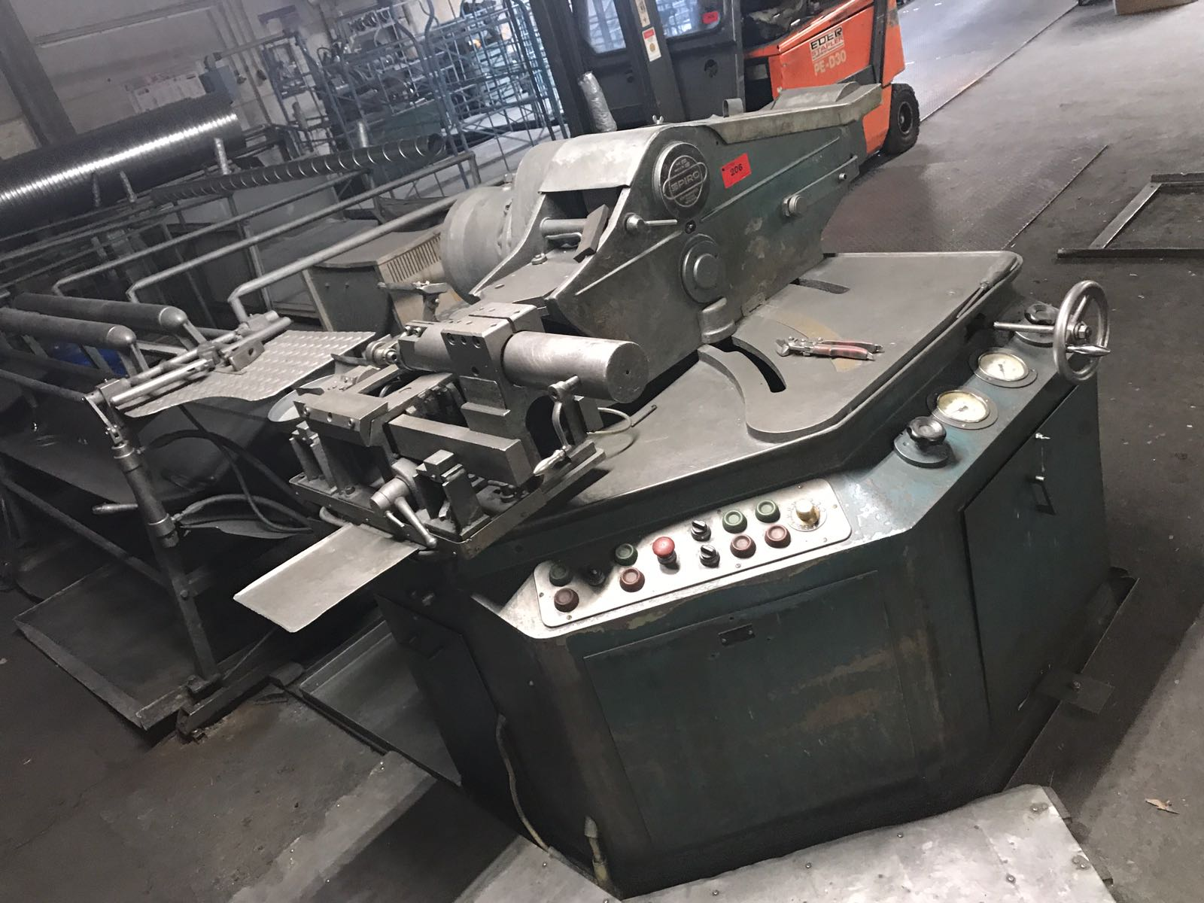
- Typ : 1600 S
- Machine No : 554
- Age : 80 er5

- Tube pipe diameter
- Minimum Ø : 80
- Maximum Ø : 1.600

- Material
- Galvanized steel : 0,4 – 1,3
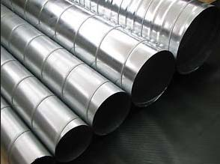
- Aluminium : 0,3 – 1,3
- Stainless : 0,3 – 0,8

- Coil 1000 Kg
- Out side Ø : 1.200
- Internal Ø : 480 – 530

- Material feed : 80.000 mm/M
- Run off table : 4.000 mm

- Dimensions
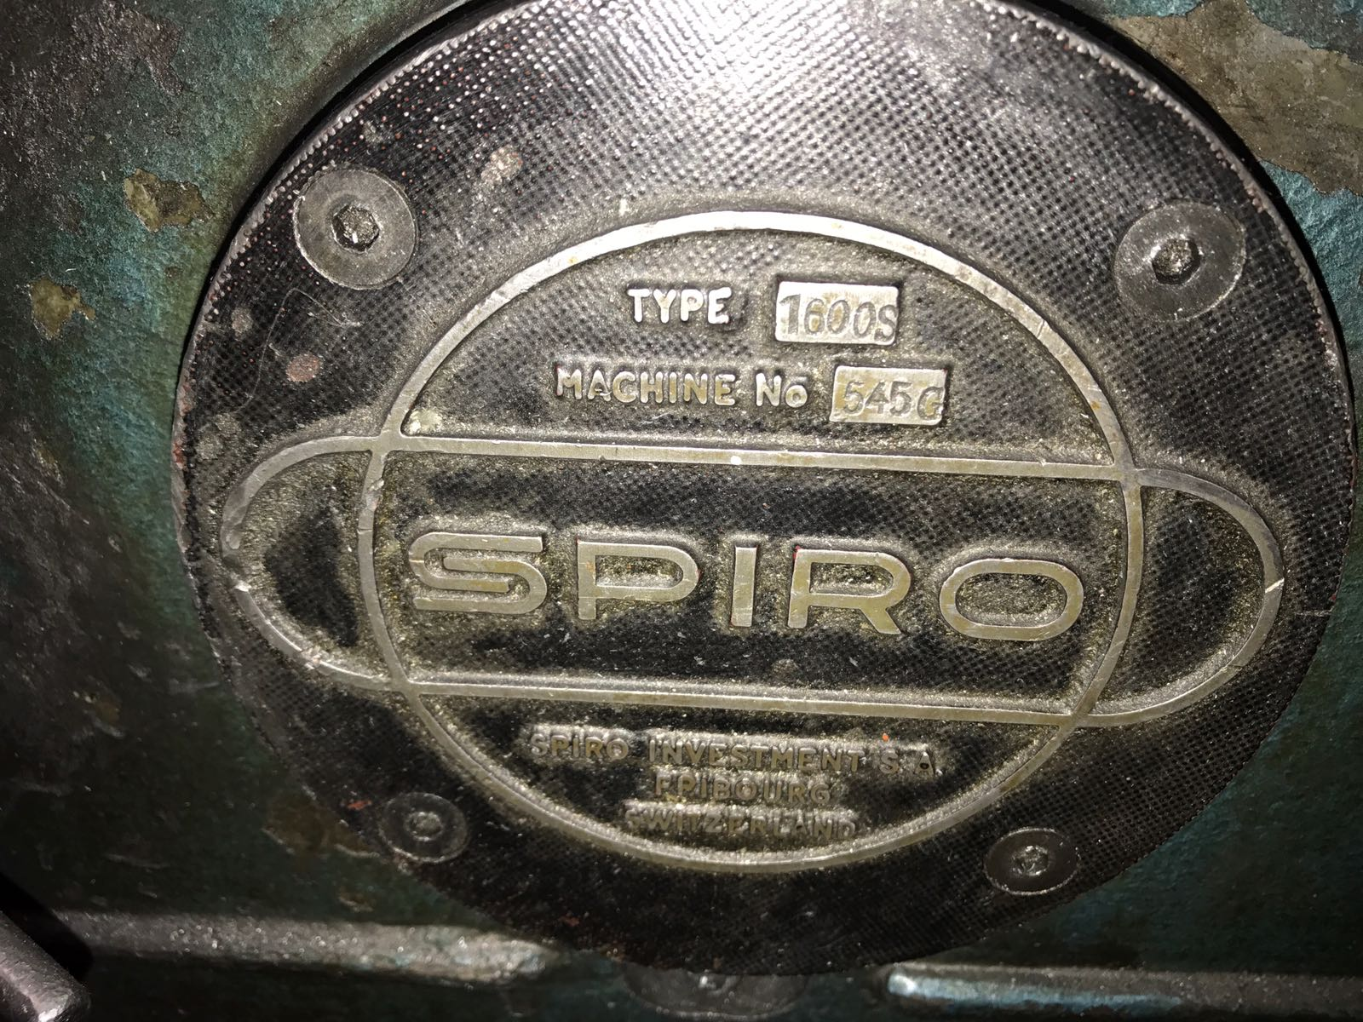
- Length : 7.000
- Width : 3.500
- Height : 1.800
- Weight : 6.000
- Power : 11 kW

- Tooling for Ø : 1400 / 1250 / 1120
900 / 800 / 710 / 500 / 300 / 200

Please Note: The above information has been obtained to the best of our ability and belief from, and from the manufacturers where possible. It is given in good faith, but its accuracy can not be guaranteed. Accordingly, it will not form a representation or constitute contractual terms. We advise you to check any vital details!

